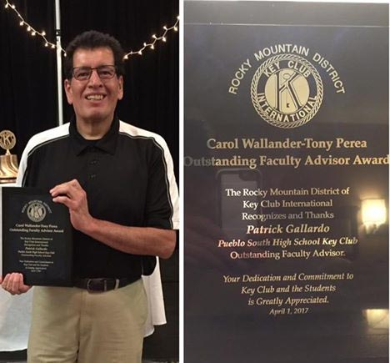
Patrick Gallardo – Named Outstanding Faculty Advisor
A well-deserved award for Patrick Gallardo. Patrick and the South High Key Club, of which he is the faculty sponsor, have always been a big supporter and partner with the Alumni Foundation.
Patrick received the Carol Wallander-Tony Perea Outstanding Faculty Advisor Award.
The Rocky Mountain District of Key Club International recognizes and thanks Patrick Gallardo, Pueblo South High School Key Club Outstanding Faculty Advisor, April 1, 2017.

